Skill Set:

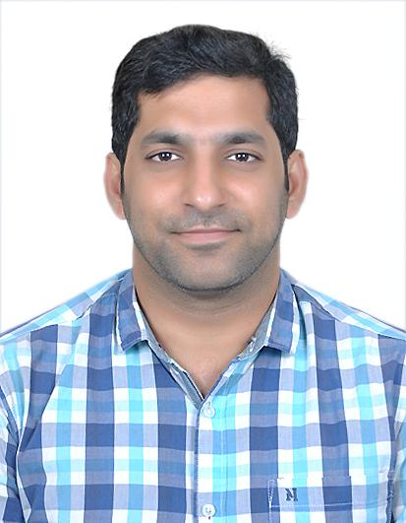

* Has hands-on experience in MVC, Layered architecture, SOA, RESTful, Message Bus, Distributed Architecture.
* Has hands-on experience in designing Workflow,

Authentication & Authorization frameworks.

* Has experience in handling cloud environments AWS, Azure.
* Has expert knowledge in using object-oriented

programming languages like Java 8.x.

* Has knowledge of Hyperledger Fabric, Ethereum.
* Experienced in Distributed systems (Apache Zookeeper, Kafka, Apache Nifi).
* Experienced in Distributed cache (Memcache).
* Experienced in UI (JSF, Spring MVC), application (Spring 4.x) and ORM (MyBatis 3.x, Hibernate 4.x) Frameworks.
* Has Good knowledge of Relational Database (Oracle 10g, 11i, SQL Server 2014, My SQL, PostgreSql 9.6).
* Experienced in using NoSQL Database (MongoDB 4.x, Elasticsearch 7.x).
* Scripting Languages – javascript.
* Experienced in using Application Servers (Web Sphere Application Server (6.1, 7.0), Glassfish 3.x, JBOSS Wildfly 8.x, Tomcat 8.5)
* Used Design Tools (Microsoft Visio, Rational Software Architect, CA Erwin) in preparing required artefacts.
* Experienced in integration of diverse Tools (Documentum 2.x, Aspose Reports 7.x, RabbitMQ 2.8.x, BIRT 4.6).

Training:

Simplilearn Certified Blockchain Developer Training – January, 2020

Work Experience: 13 years

Working in IVY Comptech Pvt. Ltd. as a Software Architect: 1 year 5 months (10th Dec, 2019 - May, 2021)

Worked in Infosys Limited as a Technology Architect: 11 years 6 months (26th May, 2008 – 29th Nov, 2019)

Experience:

Data Central Exchange (Dec, 2020 – May, 2021)

***Technology Stack:*** MongoDB 4.x, Apache Kafka 2.x, Apache Nifi, Golang 13

***Role:*** Software Architect

* Architected, designed and developed front end collector, routing and .

Analytics Engine (Dec, 2019 – May, 2021)

***Technology Stack:*** Jdk 1.7, Spring 4.x Integration, Spring 4.x, MongoDB 4.x, Apache Kafka 2.x, Snowplow Analytics Engine, ELK 7.x, Golang 13

***Role:*** Software Architect (team of 2)

* Architected, designed and developed front end collector, event data processor, routing and storage components of the event data.

Hybrid Cloud Maintenance application, an Infosys Proprietary Product (July, 2018 – Nov, 2019)

***Technology Stack:*** Jdk 1.8, Spring 4.x MVC, jQuery 1.x, Spring 4.x, Hibernate 4.x, PostGreSQL 9.6, Tomcat 8.5, Apache Kafka 2.x, BIRT 4.6, JBPM, Quartz 4.x

***Role:*** Senior Technologist and Architect (team of 8)

* Refactored Reports module and introduced BIRT tool for reporting.
* Handling Automation module to automate the workflows with possibility for scheduling.

Loyalty platform for an airport lounge management company (Sept, 2015 – June, 2018)

***Technology Stack:*** Jdk 1.7, Spring 4.x MVC, jQuery 1.x, Spring 4.x, Hibernate 4.x, SQL Server 2014, JBOSS wildfly 8.x, RabbitMQ 2.8.x, Azure (Iaas)

***Role:*** Application Architect (team of 15)

* Provided a viable architectural solution to the client by taking the criticality of business into consideration.
* Created core architecture of the application and identified the components for the project.
* Performed the role of a DBA, prepared the Database ER, maintaining production database, taking backups and sync the data from Azure cloud to offline database inhouse.
* Designed Earn Rule module, Partner maintenance and dynamic email template management.
* Designed and developed Loyalty point transaction processing and calculation module, Authentication & Authorization module.

Application to capture the inspection data keyed in by the inspector real time from the factory with feeble or no network connectivity (Oct, 2013 - Aug, 2015)

***Technology Stack:*** Jdk 1.6, Spring 3.x MVC, jQuery 1.x, Spring 3.x, MyBATIS 3.x, Oracle 11i, Glassfish 3.x, ASPOSE Reports 7.x, Documentum 2.x

***Role:*** Lead developer (team of 7)

* Was part of requirement discussions and worked with the team in defining the architecture principles to be followed.
* Designed and developed Offline processing of form data, Workflow module, Report generation, image compression.
* Was part of the trial run initiative to interact with the stake holders to understand their pain points and provided feasible solutions.

Suite of Applications to maintain Product documentation through the product lifecycle, Capture Testing/ Inspection orders online, maintain the Regulations and standards based on business lines across geographic locations, maintain testing and inspection reports (May, 2008 - Sept, 2013)

***Technology Stack:*** Jdk 1.6, JSF, jQuery 1.x, Spring 2.x, MyBATIS 3.x, Oracle 11i, WebSphere Application Server 7.0, ASPOSE Reports 7.x, Documentum 2.x

***Role:*** Team Lead of the team maintaining the application till September 2013.

* Was part of the trial run initiative to interact with the stake holders to understand their pain points and provided feasible solutions.
* Designed and developed workflow module to publish content, Aspose Pdf Report generation. Team Lead of the team maintaining the application till September 2013.
* Developed: Discussion forum, Order status tracking screen, Report generation, Batch program to perform offline generation of reports, Mailing operations, one time migration of files from file server to Documentum tool, Dynamic template management.
* Designed the Data structure to store the files in documentum, screen flow and implemented of Dynamic template management.
* Handled Database related activities like preparing the sql scripts for deployment, handling project database.

Academics:

*X Class* – **77.2%** (2001-2002) - C.B.S.E (J.Sikile School, Narsapur, West Godavari Dt., AP)

*Intermediate (+2)* – **95%** (2002-2004) - Board of Intermediate Education, A.P.

*Engineering (B.Tech.- Computer Science)* – **75%** (2004-2008) - Andhra University

Declaration

I hereby declare that all the above-mentioned details are true to the best of my knowledge.

Place: Vijayawada

Date: 14/10/2021